6.101: a) Denote the position of a piece of the spring by l; 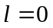 is the fixed point and 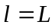 is the moving end of the spring. Then the velocity of the point corresponding to l,
denoted u, is 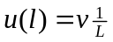 (when the spring is moving, l will be a function of time, and so u is an implicit function of time). The mass of a piece of length dl is 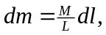 and so
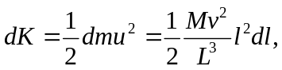
and
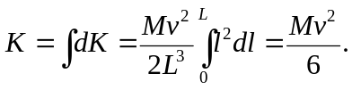
b) 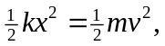 so .
c) With the mass of the spring included, the work that the spring does goes into the kinetic energies of both the ball and the spring, so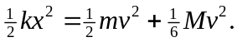 Solving for v,
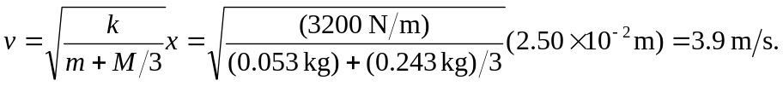
d) Algebraically,
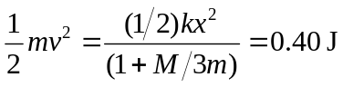 and
